Whole blood transcriptomic investigation identifies prognostic gene modules and long non-coding RNAs in sepsis

Figure S1. Identification of co-expression modules for dataset GSE65682. A) Paramater setup. B, Gene dendrogram and module colors. C) Module dendrogram.

Figure S2. Identification of co-expression modules for dataset GSE69528. A) Paramater setup. B, Gene dendrogram and module colors C) Module dendrogram.

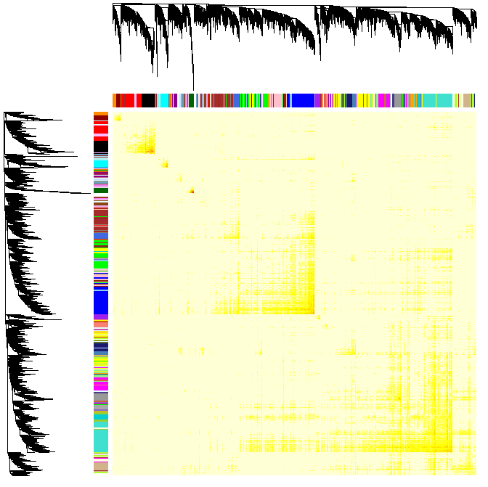
Figure S3. Identification of co-expression modules from the topological overlap matrix using WGCNA for dataset GSE69528.

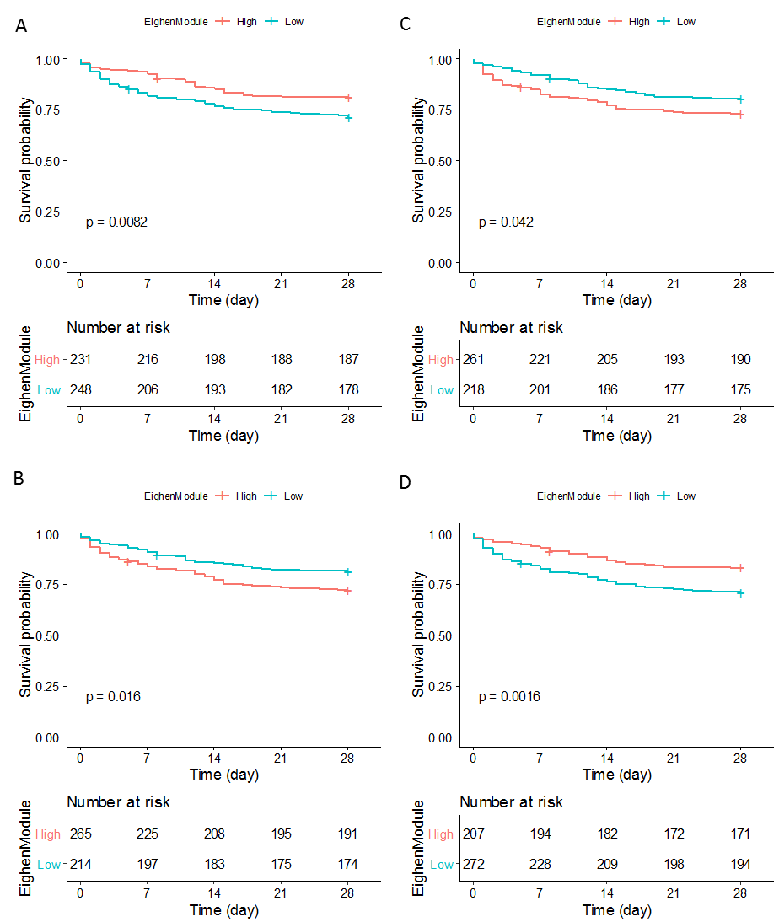
Figure S4. Kaplan–Meier curves of two patient groups with higher or lower EG value for module 15, 23, 45, and 36, respectively.

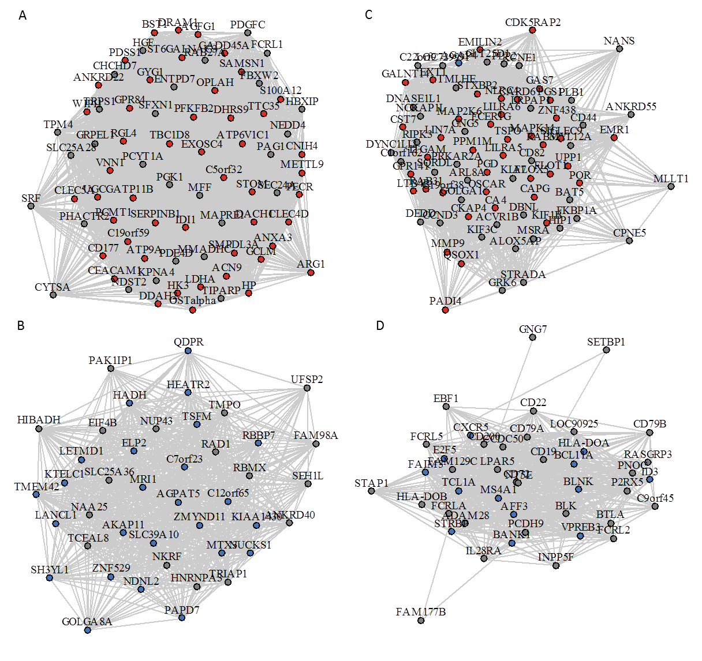
Figure S5. Example of the coexpression moudules enriched of up (31 and 37) or down-regulated DEGs (45 and 39). Vertexes correspond to genes and edges correspond to expression correlation. Only the edges with the abslute value of PCC greater than 0.5 are shown. Up-regulated DEGs are colored in red while down-regulated DEGs are in blue.

